Cos eteri, cos subtil a l’ull nu que envolta el cos físic intercanviant energies pel flux de vida
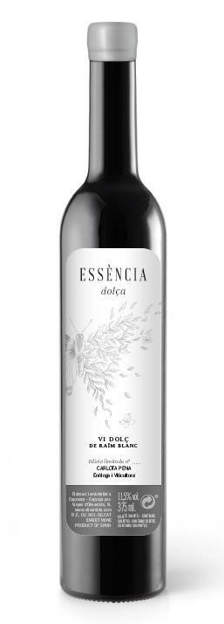
2018

Alcoholic strenght:

10
%vol.

pH:

2
,
87

Total acidity
:

8
,08 g/L

g/l of sugar:

143

g/
l

ESSÈNCIA DOLÇA 2021
50% WHITE CARIGNAN – 50% RED GARNATCHA
Essència Dolça de l'Eteri arises as a result of wanting to recover a very old technique of making sweet Empordà wine.
A plot of 110-year-old vines where we find Carignan Blanca and Grenache Roja on a sandy soil with pebbles from the old river bed.
Vineyard worked under the principles of Biodynamic Agriculture and in the most manual way possible. It is harvested by hand in 8kg boxes looking for the maximum care of the grapes.
ELABORACIÓ ANCESTRAL
We pick Carinyena Blanca and Grenache Roja at their optimal point of maturation and then stretch it on a bed of dry straw to dehydrate and generate a point of botrytis.
Then we press and let the must start to ferment with indigenous and spontaneous yeast.
Once it has started, we boil part of the must and reduce it until we get a caramel that we will later use to add back to the fermenting must, and in this way stop the fermentation of the yeasts due to excess sugar and fatigue.
TASTING NOTE
Amber color
Aromatically we find orange peel, nuts such as almonds, also notes of caramel and honey
In the mouth we have volume and sweetness with a fresh finish marked by acidity

